Big Terror Movie Themes
(MFP 50248)

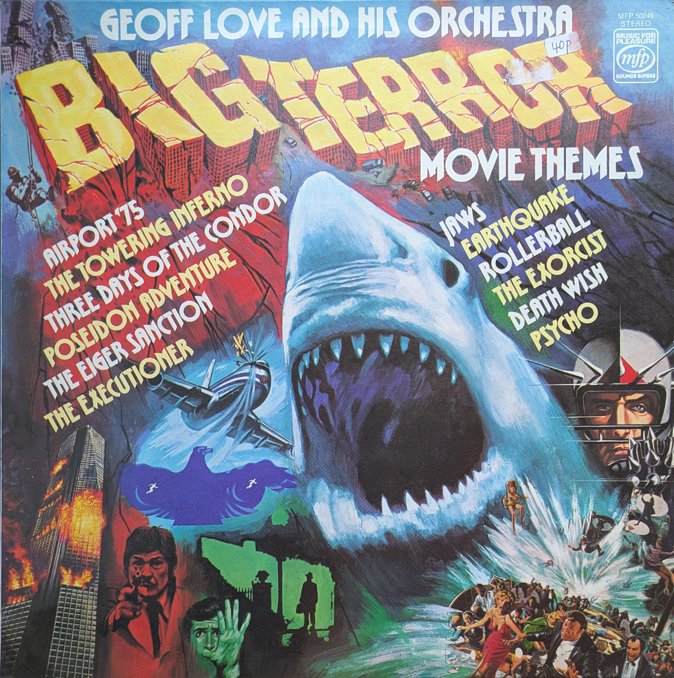
It perhaps took longer than people initially thought for the budget structure to undo itself. The shift was quite gradual but by the mid nineties you could buy all of the chart music on CD and cassette in a local Tesco. Even though it was not the same price point up to the minute releases shared the same racks as the budget labels for a time and then they were gone. Now of course it's unusual to see CDs sold in supermarkets at all.

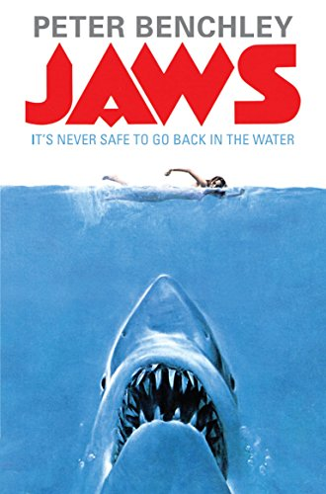
Just as the budget label era is over so to, seemingly, is that of the cheap paperback, documented in The New York Times 2026 article, "So Long to Cheap Books You Could Fit in Your Pocket." These books fuelled a massive cultural engine; for instance, a pulp thriller about a shark becomes a blockbuster with an iconic score. This leads into Geoff Love’s Big Terror Movie Themes compilation, which naturally featured the Jaws theme. Fittingly, this was to be released on a label co-founded by Paul Hamlyn; the same man behind the cheap UK paperback firm Books for Pleasure.

If you have a decent copy of this album and play it through a good stereo system it'll sound incredible. Three Days of the Condor for starters is a great piece but this whole album is beautifully arranged. The top session musicians of the day recorded by London's best engineers in a great studio.

A lot of people decry the fetishisation that has been foisted upon vinyl records throughout the last decade, and beyond. The point is pretty undeniable when you see pretty run of the mill reissues on sale for significant amounts of money. When you see DJs, Mr Thing for example, promoting cheap abundant records like this it does act as a reminder that there are some pretty extraordinary records out there. There is a glut of this particular release online, anyone can get a copy.

All of these albums were released at what is considered to be the golden era of the lp. There are all sorts of retrospectives of various genres and sub-cultures from this period, German cosmiche music, Italian film scores, obscure folk horror, the list goes on. Aside from the Sound Gallery and the odd piece picked up on various Soul Jazz compilations over the years I can’t think of any in depth retrospective of British budget labels. It must be worth looking into – just see the various different records brought together here. But it’s like MFP and Contour and Marble Arch and the like are so mundane and plentiful that they are overlooked, which is a real shame because I think it is likely that a big chunk of cultural history has vanished as a lot of people directly involved in the production of this music are no longer with us. However on the positive side these records are still here. And yes often they will generate a laugh, they might be a bit naff but there is real artistry that goes into them. These records are not shoddily produced and if for no other reason than sheer volume of catalogue they contain some brilliant recordings of music of the era.

